Psuedo Live Project (PLP)
<< Mini Project Title>>

Table of Contents
1 Problem Statement 1
2 Functional Specifications 2
3 Technical Description 4
4 Test Scripts (Test cases) 8
5 Reference Source Code 9
6 Deliverables 10

Problem Statement
The purpose of this project is to develop a scheduler. The Schedule should schedule the process based on scheduler algorithm. Scheduler consists of different modules which are as given below.

      - Configuration Tool
      - Scheduler algorithm
      - Starvation algorithm
      - Data logger

Scheduler algorithm is a core module of this project. The application could be developed both by following SDLC life cycle and IIDM Methodology.

A guideline for phase wise development plan is given below.

Phase | Description | Duration
I | - Configuration Tool | - 2 Days
II | - Scheduler algorithm development  - Integration with Phase I | - 3 Days
III | - Starvation algorithm and Integration with Phase II | - 2 Days
IV | - data logger and Integration with Phase III | - 2 days
V | - System Testing | - 2 Days

Functional Specifications
- Process schedule will depend on priority, execution time and starvation time.

- Details of the process information generated by configuration tool could be saved to a single file.

- Process information generated by configuration tool includes:

    - Process ID
    - Process Name
    - Execution time
    - Priority

- Maximum 100 processes in the file.

- Scheduler should create a queue to store all process information.

- Scheduler should create log file to store all event information.

- Scheduler schedules the process by printing information about process and allocates 10 ms (timer tick) for that process.

- Then schedule next process and so on till the end of all processes.

- Check that execution time slice completed for each process.

- If execution time is over, remove structure from queue and log information in the data logger file.

- Remove process entry into the file.

- Implement starvation algorithm

- Context switch time should not more than 10-15 us

- Single stack based design.

- Timer tick can be varying from 10 ms to 1 sec.

- Two priority levels are allowed to all processes.

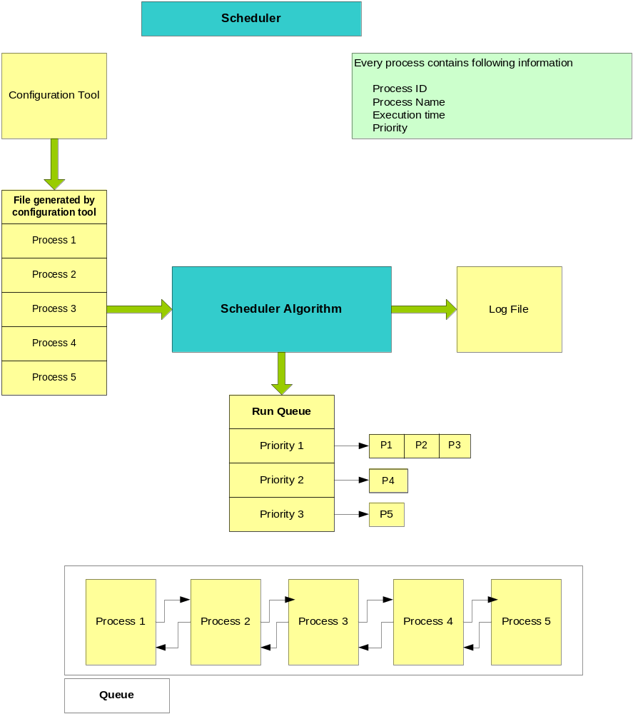

Technical Description

Detail Information of all the scheduler module given below.

A] Configuration Tool:

Option A: GUI (VB/VC based tool)

- Developer should create graphical user interface (GUI) for user input about all processes.
- User should able to enter Maximum number of processes and process detail information like process ID, Process name, Execution time and priority.
- Arrange all processes related data in a binary file or text file.
- User should able to enter timer tick (Scheduler decision time) information.
- Tool should be able to create necessary data in the file.
- Configuration tools should have browse button to select path to store the above file.
- All the data integrity check should be included in the tool itself.

Option B: Command line Interface program

      - This program should be written in C language and user should be able to enter information after execution of this program.
      - User should able to enter maximum number of Processes.
      - User should able to enter process details like Process ID, Process name, Execution time and priority one by one for the maximum processes.
- Arrange all process related data in a file.
- User should able to enter timer tick (Scheduler decision time) information.
- Program should be able to create necessary data files.
- All the data integrity check should be included in the tool itself.

Option C: Self generated configuration file

- Programmer will create a text based data file.
- Programmer can directly edit above file and will have all configuration data about all processes.
      - The file should contain information such as process ID, Process name, Execution time and priority one by one for all the process.
- Arrange all process related data in a file.
- Programmer should enter timer tick (Scheduler decision time) information.
- Programmer should take care of data integrity while editing configuration files.

B] Scheduler algorithm:

Option A: Fixed priority Round Robin Algorithm

- Algorithm should schedule the process based on timer tick value.
- Scheduler should invoke at every 10 msec. (It can be configure to 1 sec, step size is 10 msec.)
- Scheduler will select high priority process. Multiple processes with same priority should be running in round robin.
- Allocate time slice to every process one by one.
- Check if execution time of one of the process is over then remove process entry from queue as well as from configuration file.
- If none of the process is in the queue then scheduler should wait in idle loop.
- Scheduler should be continuous running program.

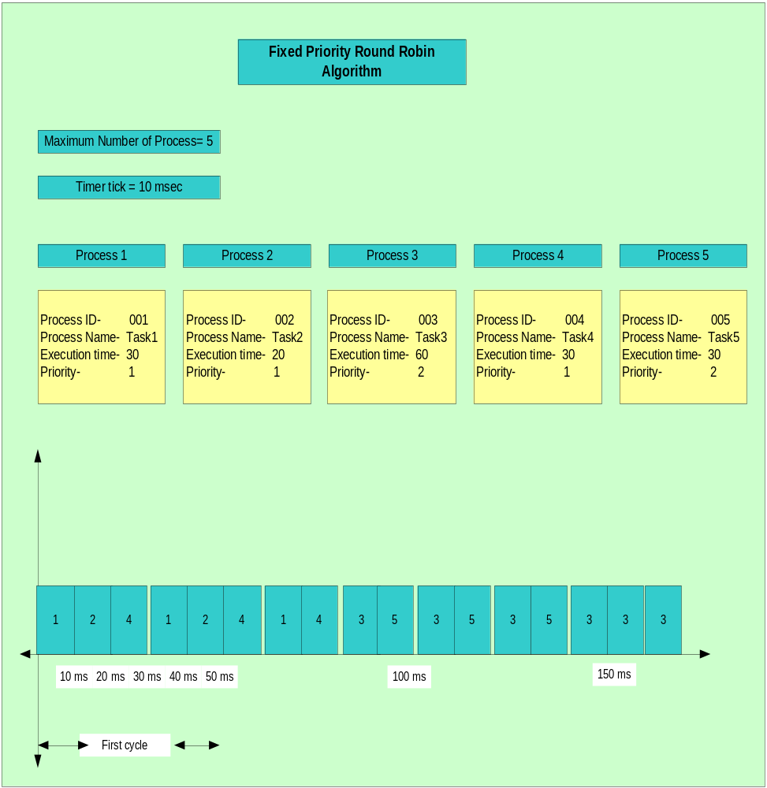

C] Starvation algorithm:

- Try to increase execution period of the high priority task and check process starvation.
- Check time stamp information in log file.
- Algorithm should not create dead lock in a system.

D] Data logger:
- Data logger should capture time stamp information of all process.
- Before starting scheduler algorithm read system time.
- Store timer tick count and use this time for time stamp
- Whenever process finished execution time, store time stamp information in a buffer.
- At the end of all processes, read system time and log information in file.
- Use data file is in append mode to capture information for next job profile.(New process schedule)

